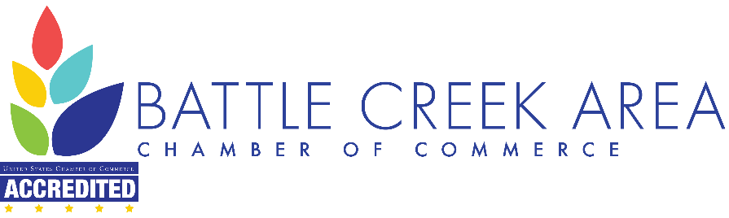
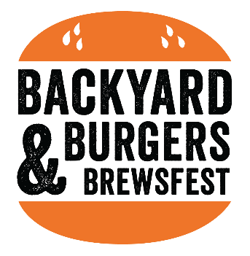

2022 Sponsorship Agreement

Business Name ________________________________________________________________________
Name of Contact Person_________________________________________________________________
Title ________________________________________________________________________________
Phone Number__________________________ Email_________________________________________
Billing Address: ________________________________________________________________________
____________________________________________________________________________________
Cell Phone Number_______________________

Sponsorship Type (Circle One)
- $5,000 Event Sponsor (limited to 1) top billing sponsorship with naming rights
- $2,500 Sound Sponsor (limited to 2) sponsor the main stage and sound for the festival
- $1,500 Band Sponsor (limited to 2) sponsor our two local bands for the evening
- $750 Beverage Sponsor (limited to 4) brand visibility, increased sales in Calhoun County
- $500 Food Truck Sponsor (limited to 20) with a goal of 20 food trucks for the festival help us bring a variety of great eats to the festival
- $300 Game Sponsor (limited to 4) bring the backyard fun to the festival by supporting the fun

Payment Method (Circle One) all payments must be received by no later than August 5, 2022
- Check
- Credit Card
- PayPal
- Send Invoice

Authorizing Person’s Signature___________________________________________________________

Please email your company logo to office@battlecreek.org for promotional materials

